|  |  |  |  |  |
| --- | --- | --- | --- | --- |
| **EMB00004e70326a** | | **Data Convergence ∙Consumer Research Expert**  **ConsumerInsight Report** | | |
| Company | ConsumerInsight | | E-mail | kimmh@consumerinsight.kr |
| Query | Kim, Minhwa Director | | Contact | 02) 6004-7643 |
| Issued | Tuesday, April 18th, 2024 | | Pages | Total of 6 pages |

|  |  |  |
| --- | --- | --- |
|  | **Satisfaction with overseas travel destinations for Japan increased and the USA fell… Why?**  **ConsumerInsight compares satisfaction with overseas destinations  by country in 2023** |  |
|  | **- Switzerland and Spain, regained 1st and 2nd places respectively, following their pre-COVID-19 rankings in 2019**  **- Top rankings belong to Europe and the South Pacific, while the lowest rankings are for China and Southeast Asia**  **- Japan rose by 18 places to 6th due to weakened Yen and diminished ‘No-Japan’ sentiment**  **- The rankings of the US dollar-using regions, including the USA, Hawaii and Saipan fell sharply**  **- Cost factors from fluctuations in exchange rates and prices have influenced satisfaction** |  |

○ This year, Switzerland was the country with the highest satisfaction rate among overseas travelers, followed by Spain. Satisfaction rates for Asian countries, including Japan, experienced a significant increase, while those in the 'dollar zone' such as the United States, Hawaii, and Saipan, saw a notable decline. Overseas travel satisfaction is much higher than domestic travel, and it is expected that the concentration to the overseas travel market will be intensified after the endemic of COVID-19.

□ The travel research firm ConsumerInsight conducts an annual study on satisfaction with overseas travel destinations every September. The firm inquire 9,375 individuals who have traveled abroad in the past 1 year (from September 2022 to August 2023) about the satisfaction levels of their destination country, as well as their willingness to recommend their destinations to others. The firm get the overall satisfaction scores (out of 1000 points) for 27 countries with a sample size of over 60 respondents. While this study has been conducted annually since 2018, no results were published during the significantly restricted travel period due to COVID-19 (2020-2022). PCR testing upon entry has been lifted in Korea since October 2022, enabling the resumption of overseas travel. Hence, this study is publicly released for the first time in four years since 2019.

□ The data and the study results are being made publicly available through the Cultural Big Data Platform MarketC (www.bigdata-culture.kr), established as part of the Big Data Center Construction Project by the National Information Society Agency (NIA) in South Korea.

**■ Satisfaction by Country: Switzerland leads Spain by 23 points**

○ Switzerland (833 points) took the top spot in overall satisfaction by country, with Spain (810 points) following in 2nd place**[Figure]**. In 2018 and 2019 studies, before COVID, Switzerland maintained its position as 1st for two consecutive years, while Spain held 2nd place. Both destinations have consistently been highly satisfying for Korean travelers. Compared to 2019, Switzerland saw a decrease of 10 points while Spain experienced an increase of 10 points, yet the difference remained significant at 23 points.

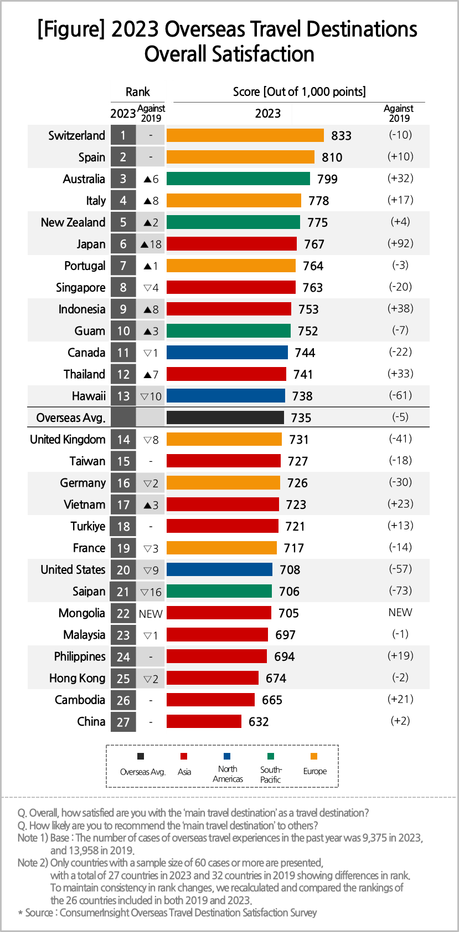

○ Following them, Australia (799 points, 3rd place), Italy (778 points, 4th place), and New Zealand (775 points, 5th place) trailed behind. Japan climbed to 6th place with 767 points, marking an 18-step vertical rise compared to 2019. Following Japan, Portugal (764 points), Singapore (763 points), Indonesia (753 points), and Guam (752 points) made it to the top 10 in that order. By continent, Europe had 4 countries, while the South Pacific and Asia each had 3 countries represented in the top 10 destination.

○ The satisfaction with overseas travel destinations was significantly higher than domestic ones. The average satisfaction score for oversea travelers was 735 points, which was nearly on par with Busan (736 points), the top-ranking city among the 16 provinces in South Korea, and 40 points higher than the Korean average (695 points). It is no surprise that people prefer overseas travels, which offer much higher satisfaction even at the cost of more money and time.

**■ Japan rose by 92 points, while Saipan fell by 73 points, Hawaii by 61 points, and the United States by 57 points**

○ The biggest increase in satisfaction was in Asia, particularly Japan which scored 767 points. This was Japan’s highest score since the study began, with a 92-point increase from 675 points in 2019, affected by the onset of the No-Japan movement. It also surpasses the pre-pandemic year of 2018 by 27 points, which stood at 740 points. This is largely due to the fading of "No-Japan" sentiment and cheaper local prices due to the impact of the weaker yen. Among other Asian countries, Indonesia and Thailand made significant gains in both ranking and score. However, China and other Southeast Asian countries (Cambodia, Hong Kong, Philippines, and Malaysia) remained at the bottom tier.

○ Hawaii (738 points), the United States (708 points), and Saipan (706 points) have shown significant drops of 61, 57, and 73 points, respectively, while Guam (752 points) also showed a slight decline. These places are all areas where the U.S. dollar is commonly used, where the traveling costs are significantly increased.

**■ The influence of the factor ‘prices’ to the satisfaction increased the most**

○ The reason for significant fluctuations in rankings and scores of mid-ranking countries, excluding top and bottom tiers, ultimately boils down to differences in ‘travel costs’ due to changes in prices and exchange rates. Considering the importance of the six factors that constitute the pleasantness of the travel environment (prices, transportation, cleanliness, convenience, safety, language), the importance of ‘prices’ increased significantly from 14% in 2019 to 19% in 2023. On the other hand, the importance of other factors either decreased or remained almost unchanged.

○ The other major factor contributing to cost increases is the rise in airfares. While this varies depending on the destination, North America saw a 42% increase from 2019 to 2023.

**■ Share of Asian countries will be increased further**

○ While the overall average decline wasn't significant, satisfaction tended to be decreased in locations where travel expenses rose highly. Satisfaction notably declined in North America, where costs increased significantly, whereas Asia, where cost increases were relatively lower, generally experienced an uptick in satisfaction. It's anticipated that the share of Asia in the overseas travel market will continue to grow.

|  |
| --- |
| ConsumerInsight provides professional and scientific research services required in various industries such as automotive, telecommunications, shopping/retail, tourism/travel, finance, etc., through **efficient** large-scale online panels for **non-face-to-face surveys**. We focus on enhancing the value of **diverse** big data by **integrating** it with **panel research data** and applying it to various industries. Especially recently, we have **launched** the '**KD-Panel**,' a survey platform with a **100% mobile-based** **national representative sample**, and **opened it for use by anyone in the survey industry.** |

This result is based on the "Annual Summer Vacation Travel Satisfaction Survey," conducted by ConsumerInsight Consumer Trends Research Institute targeting over 25,000 travel consumers every September. The survey results and analysis reports, updated annually, can be viewed at <https://www.consumerinsight.co.kr/eleisure-travel>, and materials summarizing the survey results from 2017 to 2023 are also available for download. ([Download Report](https://www.consumerinsight.co.kr/eleisure-travel/r_report))

---------------------------------------------------------------------------------------------------------------------

Copyright ⓒ Consumer Insight. All rights reserved. The copyright of this material belongs to ConsumerInsight, and it cannot be used for commercial purposes other than reporting.

|  |  |  |
| --- | --- | --- |
| **For-more-Information** | | |
| Kim, Minhwa Research Director/Ph.D | kimmh@consumerinsight.kr | 02)6004-7643 |
| Hyun, Sori Assistant Manager | hyunsr@consumerinsight.kr | 02)6004-7658 |